**Ethics Canvas Workspace**

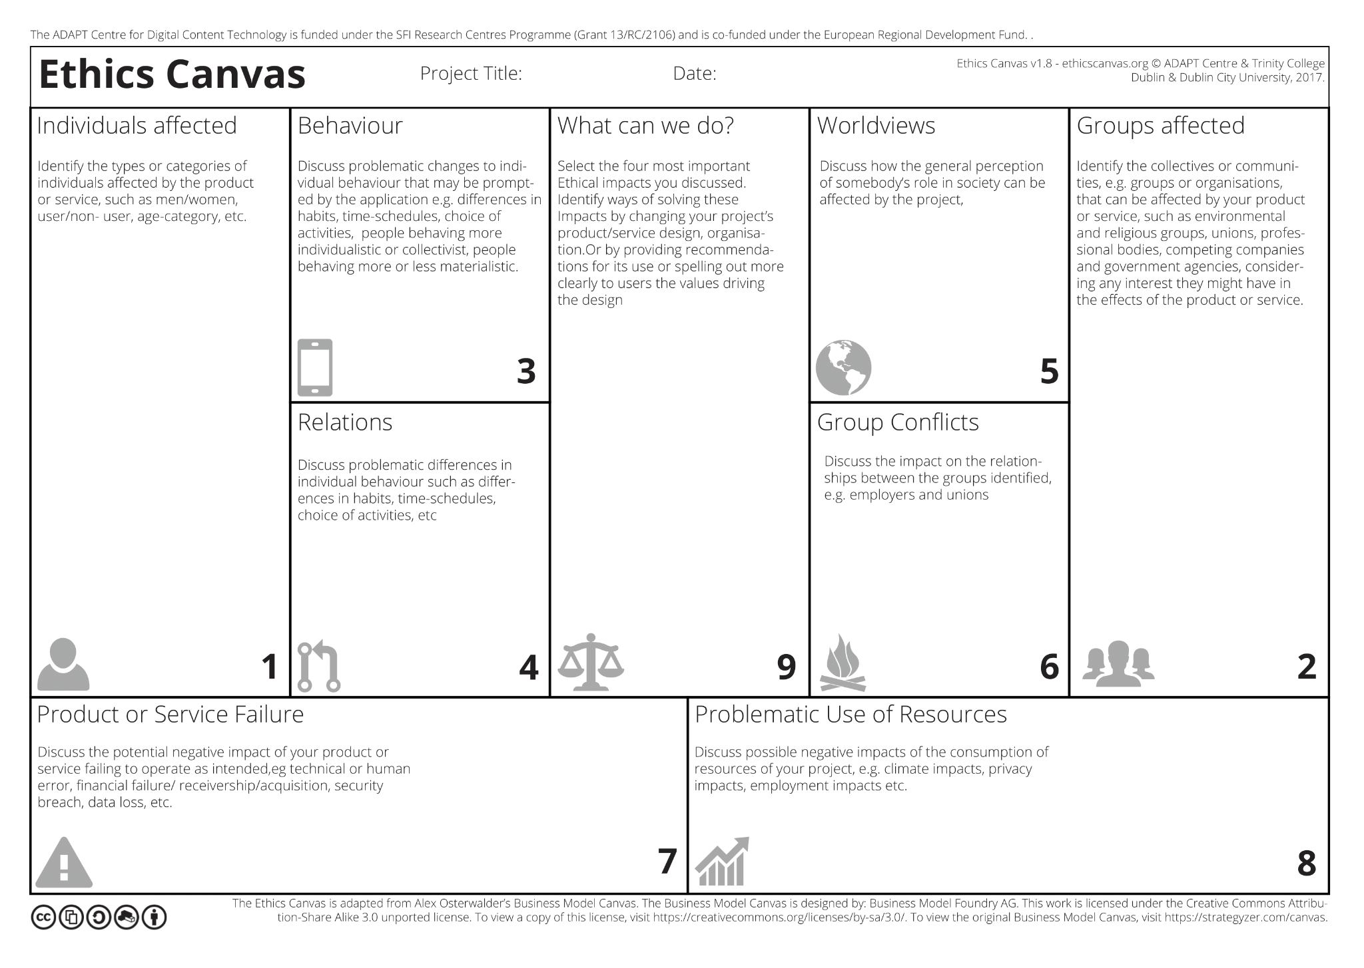

**Segment 1: Individuals Effected**

Identify the types or categories of individuals affected by the product or service, such as men/women, user/non- user, age-category, etc.

Users:

* Anyone with a smartphone and a method of online payment.
* Expected to be mostly younger individuals

Retailers:

* Any restaurant/stores with consumables/food products that can be
* delivered and requires fast direct delivery. (i.e., restaurants, bakeries,grocery shops).
* Primarily retailers that don't have/need a permanent inhouse delivery service.

Delivery personnel:

* Users who facilitate the delivery from the endpoints for
* compensation.
* Gig workers of various ages with a means of transport suitable
* for the delivery

**Segment 2: Groups Effected**

Identify the collectives or communities, e.g., groups or organisations that can be affected by your product or service, such as environmental and religious groups, unions, professional bodies, competing companies and government agencies, considering any interest they might have in the effects of the product or service.

**Younger Demographic:**

* Research shows that the younger demographic make use of the majority of fast food delivery, this results in diet related diseases(cardiovascular,diabetes,cancer). Also data may be collected on the consumers showing information such as eating habits

**Environment:**

* The environment suffers due to multiple aspects of fast food delivery,single use packaging such as plastic, styrofoam and aluminium are all problematic for the environment. meat, dairy and eggs account for the majority of ingredients in fast food,its exponential increase in consumption hugely impacts environmental degradation as livestock accounts for 15% of human induced emissions.

**Restaurants:**

* Restaurants suffer from multiple aspects of fast food delivery. Restaurants recieve high amounts of bad reviews as food quality decreases while being transported from restaurant to the consumer. Restaurants also suffer due to fast food delivery applications collecting data on business performance

**Segment 3: Behaviour**

Discuss problematic changes to individual behaviour that may be prompted by the application e.g., differences in habits, time-schedules, choice of activities, people behaving more individualistic or collectivist, people behaving more ,or less materialistic.

* Simplified access to not necessarily healthy food
* Some retailers might switch from inhouse delivery to app, permanent jobs might be passed on to the gig economy losing insurance, benefits, etc.
* Creates a competitive system for deliveries that can negatively affect work for some workers. Delivery/delivrer balance needed to provide sufficient service while ensuring that those working can make money reliably enough to dedicate time for it a loss in balance can create a problem

**Segment 4: Relations**

Discuss problematic differences in individual behaviour such as differences in habits, time-schedules, choice of activities, etc.

* Must have drivers/food available morning to night to accommodate for early risers and night shift workers alike.
* Must ensure people who are vegan/vegetarian or are of a religious group with dietary restrictions are catered too and their wishes respected. The app must ensure that there is no order mixing and food isn’t allowed to touch.
* Contact free delivery must be made a priority for those who choose that option, such as people who are immunocompromised.

**Segment 5: World views**

Discuss how the general perception of somebody’s role in society can be affected by the project,

* Consumption of fast foods may be seen as a replacement for cooking or as more common and appropriate on a regular basis
* Social norms may be associated with higher fast food consumption (e.g takeaways on friday’s)
* In some religions food is seen as sacrate so a fast food service may seem disrespectful or non inclusive (e.g. no halal options, etc.)
* Concerns with loss of location privacy (address entered to order)

**Segment 6: Group Conflicts**

Discuss the impact on the relationships between the groups identified, e.g., employers and unions.

* New channel for bullying based on type of food ordered by a person
* Automated payment and customer support system could put employees out of work
* Locally hired delivery drivers could loose work due to fast food delivery services hiring their own drivers and deliveries being assigned to them

**Segment 7: Product or Service Failure**

Discuss the potential negative impact of your product or service failing to operate as intended, e.g., technical or human error, financial failure/ receivership/acquisition, security breach, data loss, etc.

* May have miscommunication between drivers and customers on delivery location, leading to longer wait times and misdeliveries leading to customer and driver dissatisfaction alike.
* If a security breach were to occur, it could be disastrous as it would reveal customers name, address and phone numbers. We could avoid most sensitive information like card information being breached by handling our payments via Stripe or an equivalent.
* Restaurants often get orders wrong and as delivery drivers are forbidden from handling customers' food are unable to check that an order is correct. Customers would rightfully be upset and may misdirect their frustration towards the service itself instead of the restaurant.
* If wait times are long, during rush hours for example, food could get cold which could lead to complaints.
* Food delivery is a very competitive business, with many companies vying for the top spot. A lot of these services operate at a loss in an effort to aggressively expand and are only afloat due to venture capital funds seeking future returns. Without this funding, the service may face financial failure.

**Segment 8: Problematic Use of Resources**

Discuss possible negative impacts of the consumption of resources of your project, e.g., climate impacts, privacy impacts, employment impacts etc

* Customers place orders on their smartphones and through meal delivery applications like DoorDash and Uber Eats. Credit card numbers and other sensitive information are often exchanged and stored across a number of networks and systems.
* The COVID era has resulted in systemic exploitation and appalling working conditions for those who deliver food. Additionally, low pay (and benefits), a lack of welfare programs, and discriminatory policies affect platform workers.
* Most of the time, delivery of food ordered online call for single-use packaging. This packaging must be produced, moved, and disposed of using a significant amount of energy and raw resources. When the materials are burned or decompose in a landfill or the environment, huge amount of emissions are released.

**Segment 9: What can we do?**

Select the four most important Ethical impacts you discussed. Identify ways of solving these Impacts by changing your project’s product/service design, organisation. Or by providing recommendations for its use or spelling out more clearly to users the values driving the design

* Keep users data safe by encrypting it and introducing two factor authentication to avoid data breaches. This could be done by employing a cyber security company to make sure that safe practices are maintained.
* Pay delivery workers a basic wage regardless of how many deliveries they are able to complete in order to create a less competitive work environment
* Allow restaurants to employ their own delivery drivers, allowing restaurants to hire local workers
* Introduce an options in the settings where you can select your dietary requirements (eg. Vegan, Kosher, etc.) So that only the food that you are able to eat shows up on the app.